Russell Emery Blair
August 21, 1907 – February 7, 1996

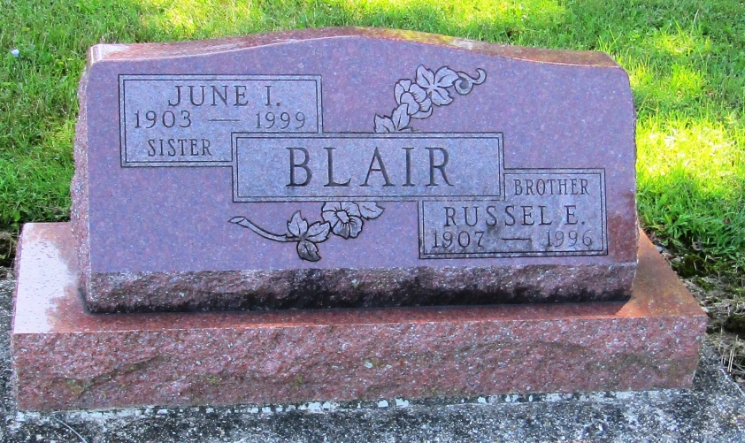

Russell E. Blair, 89
Huntington resident Russell E. Blair, 89, died at 11:30 p.m. Wednesday at Wells Community Hospital. Born Aug. 21, 1907 in Preble County, Ohio, he was the son of Charles Emery and Flora Bell Fudge Blair.
He was the owner and operator of Blair Garage and a farmer. He was also a member of the First Baptist Church in Warren.
He is survived by two brothers, Paul Blair and George Elza Blair of Warren; four sisters, Neoma Cloud of Warren, June Irene Blair of Portage, Mrs. Harold (Mary Ellen) Beck of Markle and Mrs. Sussie Grace Stock of Marion; and several nieces and nephews. Two sisters, Pearl James and Blanche Souers, preceded him in death.
Calling will be from 2 to 4 and 6 to 8 p.m. Friday at Bergman-Glancy H. Brown & Son Funeral Home in Warren. Services will be at 11 a.m. Saturday at the funeral home with Rev. Dan Cash officiating. Burial will be at Mossburg Cemetery in Wells County.

News Banner, Wells County, Indiana
Thursday, February 8, 1996

