Glen Blair
April 7, 1919 – April 7, 1919

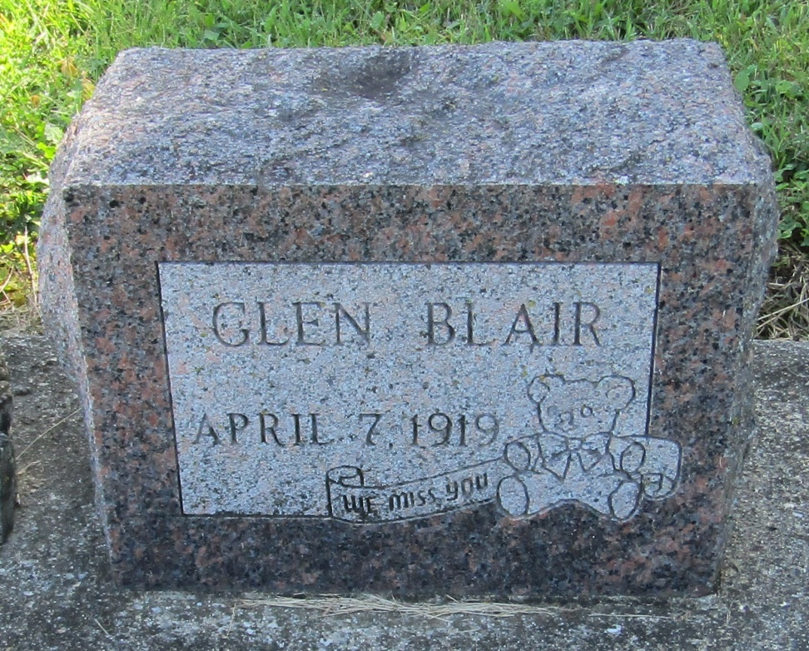

Glem Blair
in the Indiana, Death Certificates, 1899-2011
Name: Glen Blair
Gender: Male
Race: White
Age: 0
Marital status: Single
Birth Date: 7 Apr 1919
Birth Place: Ind
Death Date: 7 Apr 1919; stillbirth
Death Place: Salamonia, Huntington, Indiana, USA
Father: Elmery Blair
Mother: Flora Fudge
Burial: April 7, 1919; Mossburg Cemetery

