Lewis Myron Beerbower
September 16, 1859 – September 8, 1938

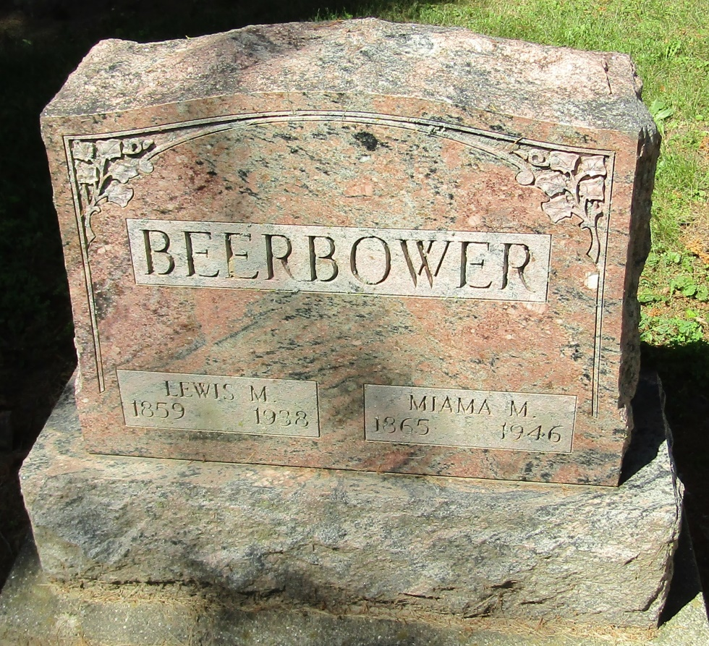

Lewis Myron Beerbower
in the Indiana, Death Certificates, 1899-2011
Name: Lewis Myron Beerbower
Gender: Male
Race: White
Age: 78
Marital status: Married
Birth Date: 16 Sep 1859
Birth Place: Indiana
Death Date: 8 Sep 1938
Death Place: Liberty, Wells, Indiana, USA
Father: Moses Beerbower
Mother: Cyntha A Hubbard
Spouse: Miami M Buckner
Informant: Mrs. L. M. Beerbower; Liberty Center
Burial: September 10, 1938; Mossburg Cemetery

