Ivan DeWayne Beeks, Sr.
April 8, 1930 – May 21, 1997

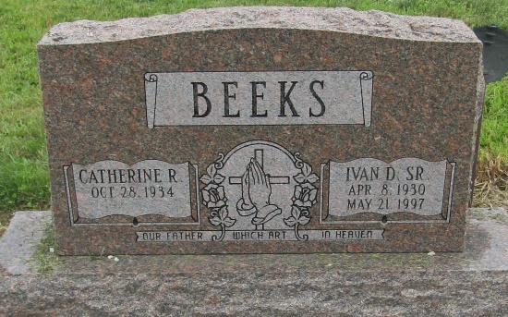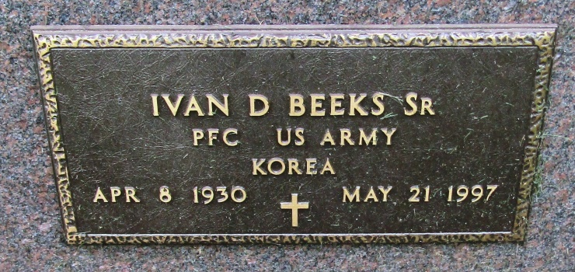

Ivan DeWayne Beeks Sr
in the Indiana, Death Certificates, 1899-2011
Name: Ivan DeWayne Beeks Sr
Gender: Male
Race: White
Age: 67
Marital status: Married
Birth Date: 8 Apr 1930
Birth Place: Roll, IN
Death Date: 21 May 1997
Death Place: Liberty Center, Wells, Indiana, USA
Father: Clayton E. Beeks
Mother: Pearl M. Fetty
Spouse: Catherine R. Hancock
Informant: Catherine Beeks; Liberty Center, Indiana
Burial: May 24, 1997; Mossburg Cemetery; Liberty Center, Indiana

