Myrtle Bell (Allen) Barton
1880 – February 15, 1956

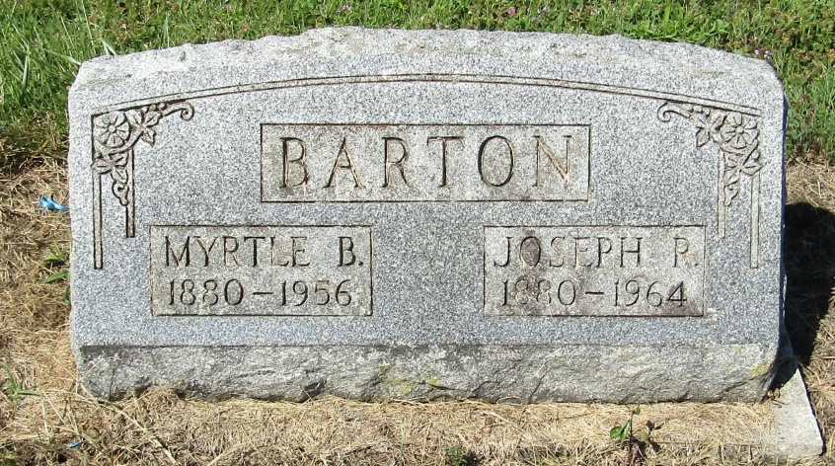

Mrs. Myrtle Barton, 75, Succumbs at Her Home

Mrs. Myrtle Bell Barton, 75, wife of Joseph Barton, died early Wednesday morning at her home, 808 Center St., following an extended illness.
Mrs. Barton was born in Bluffton and came to Muncie from Montpelier 34 years ago.
Surviving besides the husband are a son, James W. Barton of Converse; a brother, John Allen of Muncie; four sisters, Mrs. Jennie Jacobs, Mrs. Rachel Britt and Mrs. Margaret Phillips, all of Muncie, and Mrs. Ruth Edgecomb of Pennville, and two grandchildren.
The family will receive friends after noon Thursday at Piepho Funeral Home, where funeral services will be conducted at 2 p.m. Friday. The Rev. O. L. Hartman will officiate, with burial in Mossburg Cemetery near Liberty Center.

Muncie Evening Press, Delaware County, Indiana
Wednesday, February 15, 1956
Page 18

