Joseph R. Barton
October 31, 1880 – February 5, 1964

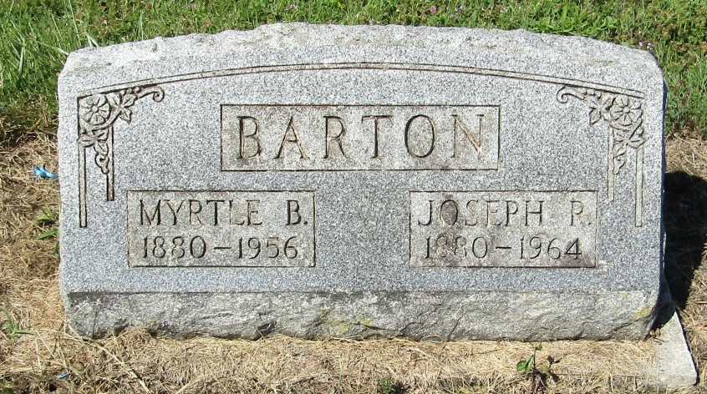

Joseph R Barton
in the Indiana, Death Certificates, 1899-2011
Name: Joseph R Barton
Gender: Male
Race: White
Age: 83
Marital status: Widowed
Birth Date: 31 Oct 1880
Birth Place: Bluffton Ind
Death Date: 5 Feb 1964
Death Place: Muncie, Delaware, Indiana, USA
Father: John W Barton
Mother: Sarah
Informant: Donald Wall; friend; Muncie, Indiana
Burial: February 7, 1964; Mossburg Cemetery; Liberty Center, Indiana

