Jacob Edward Baker
March 19, 1869 – May 6, 1958

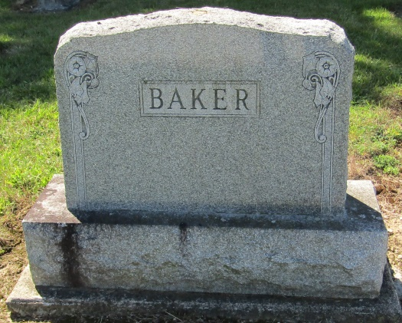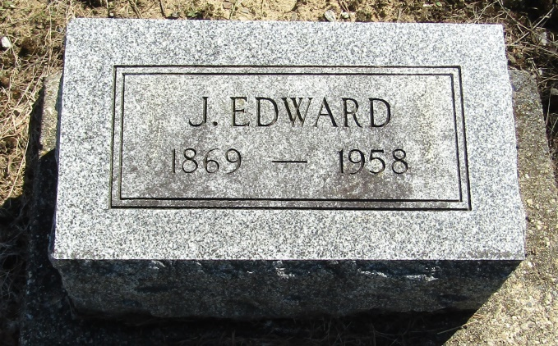

Jacob Baker
in the Indiana, Death Certificates, 1899-2011
Name: Jacob Baker
Gender: Male
Race: White
Age: 89
Birth Date: 19 Mar 1869
Death Date: 6 May 1958
Death Place: Bluffton, Wells, Indiana , USA
Father: Jacob Baker
Mother: Pheraby Hunicutt
Informant: none
Burial: May 8, 1958; Mossburg Cemetery; Wells County, Indiana

