Stella Mae (Stotler) Atkins
November 29, 1882 – May 22, 1966

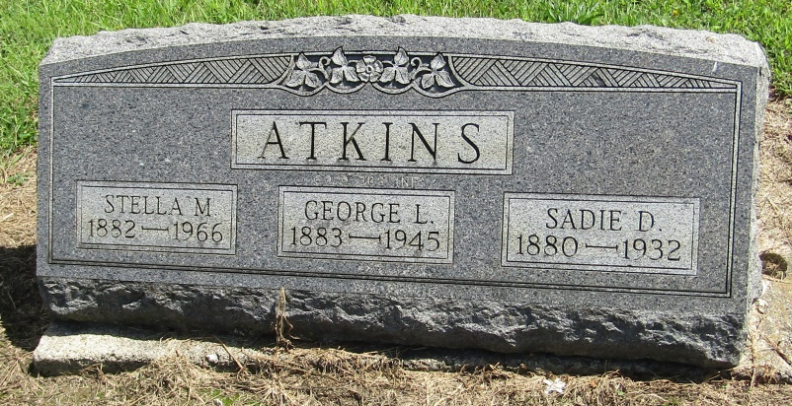

Stella May Atkins
in the Indiana, Death Certificates, 1899-2011
Name: Stella May Atkins
[Stella May Stotler]
Gender: Female
Race: White
Age: 83
Marital status: Widowed
Birth Date: 29 Nov 1882
Birth Place: Crane Co, Ind
Death Date: 22 May 1966
Death Place: Bluffton, Wells, Indiana, USA
Father: John Stotler
Mother: Jennie Palmer
Informant: Mr. Ray Mossburg; Liberty Center, Indiana
Burial: May 25, 1966; Mossburg Cemetery; Liberty Center, Indiana

