William C. Arnold
February 15, 1853 – June 15, 1918

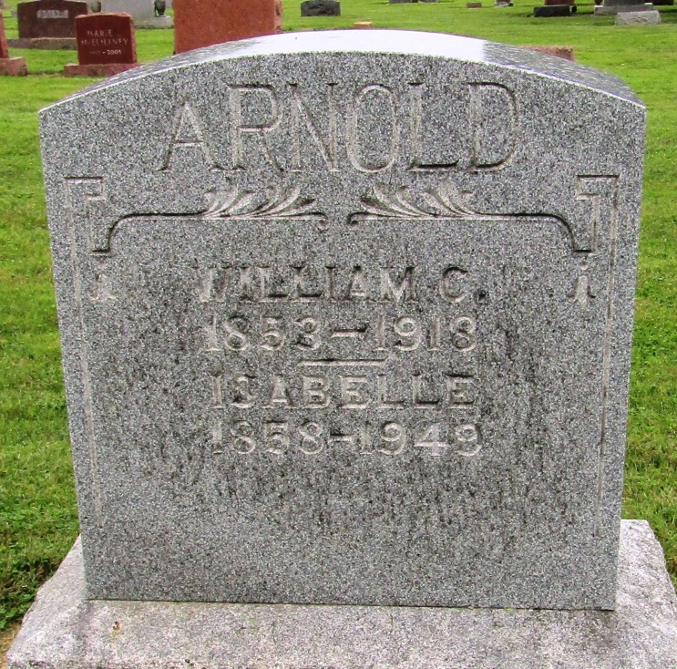

William C. Arnold
in the Indiana, Death Certificates, 1899-2011
Name: William C. Arnold
Gender: Male
Race: White
Age: 65
Marital status: Married
Birth Date: 13 Feb 1853
Birth Place: Wells County Ind
Death Date: 15 Jun 1918
Death Place: Liberty, Wells, Indiana, USA
Father: Augusta Arnold
Mother: Augusta
Spouse: Bell Higman
Informant: Bell Arnold; Liberty Centery, Indiana
Burial: June 17, 1918; Mossburg Cemetery

