Nancy L. (Mathews) Armstrong
July 15, 1937 – September 24, 1990

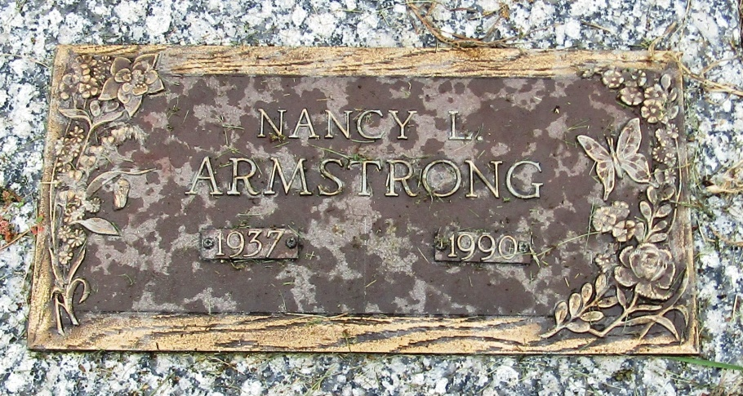

Nancy L Armstrong
in the Indiana, Death Certificates, 1899-2011
Name: Nancy L Armstrong
[Nancy L Mathews]
Gender: Female
Race: White
Age: 53
Marital status: Married
Birth Date: 15 Jul 1937
Birth Place: Liberty Center, In
Death Date: 24 Sep 1990
Death Place: Fort Wayne, Allen, Indiana, USA
Father: Fred Mathews
Mother: Gayle Melling
Spouse: Phillip N Armstrong
Informant: Phillip N. Armstrong; husband; Fort Wayne, Indiana
Burial: September 29, 1990; Mossburg Cemetery; Liberty Center, Indiana

