Stephen Allen
December 27, 1852 – January 28, 1914

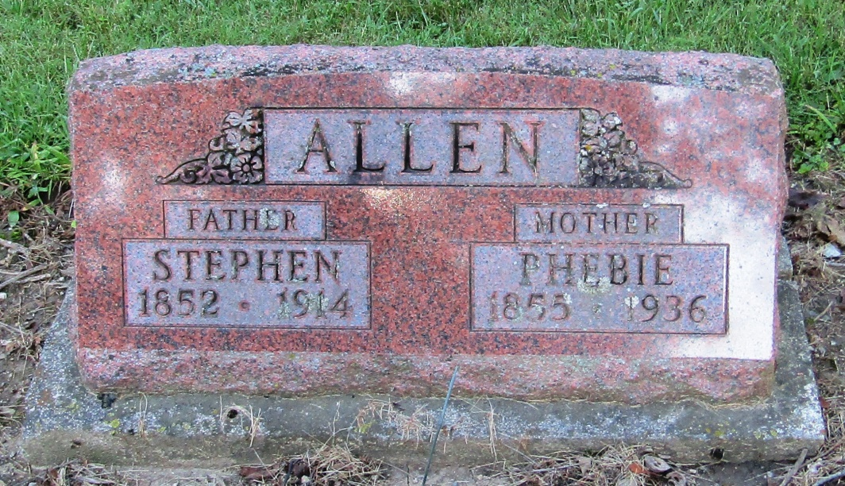

Stephen Allen
in the Indiana, Death Certificates, 1899-2011
Name: Stephen Allen
Gender: Male
Race: White
Age: 61
Marital status: Married
Birth Date: 27 Dec 1852
Birth Place: Ind
Death Date: 28 Jan 1914
Death Place: Bluffton, Wells, Indiana, USA
Father: J M Allen
Mother: Eliz. E Martin
Spouse: Phoebe McBride
Informant: Family; Bluffton, Indiana
Burial: January 30, 1914; Mossburg Cemetery

