Wanda Gregg
February 6, 1925 – April 10, 2000

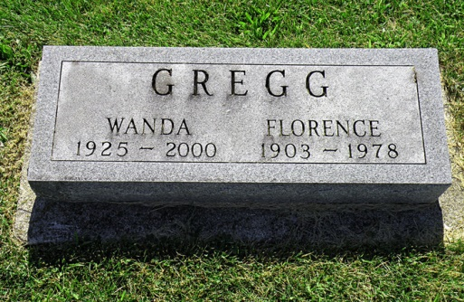
Photo by Scott Shoup

Wanda Gregg, 75, of Bluffton, who had worked at Bi-County Services, died Monday, April 10, 2000, at Wells Community Hospital in Bluffton.
The Wells County native is survived by a brother, Robert Gregg of Markle.
Services are 10:30 a.m. Wednesday at Goodwin Memorial Chapel, Bluffton, where calling is from 4 to 8 p.m. today. Burial will be at Hoverstock Cemetery, Zanesville.
Memorials are to Bi-County Services.
News-Sentinel, Allen County, Indiana
April 11, 2000

*****
Indiana, U.S., Death Certificates, 1899-2011
Name: Wanda Gregg
Gender: Female
Race: White
Age: 75
Marital status: Single
Birth Date: 6 Feb 1925
Birth Place: Wells Co, Indiana
Death Date: 10 Apr 2000
Death Place: Bluffton, Wells, Indiana, USA
Death Registration Date: 2000
Father: Harold Gregg
Mother: Florence
Informant: Nile Bucher; friend; Bluffton, Indiana
Burial: April 12, 2000; Hoverstock Cemetery; Zanesville, Indiana

