Lee F. Gibson
April 5, 1928 – February 5, 2014

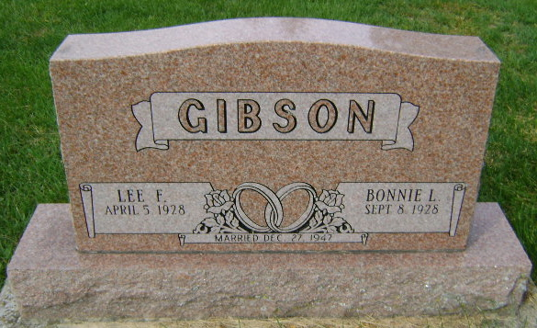
Photo by Bruce Sonner

Lee F. Gibson, 85, of Ossian, passed away, February 5, 2014. He was born on April 5, 1928 in Allen County to the late John M. and Vera (Wickliffe) Gibson. He worked as a farmer and retired from G&L Corporation.
Surviving family include his wife of 66 years, Bonnie Gibson; children, Candace Weiss, Kevin (Pamela) Gibson, Kathleen Gibson; 7 grandchildren, 6 great grandchildren, and 1 step great grandchild.
A funeral service will be 10:00 am on Monday, February 10, 2014 at Elzey-Patterson-Rodak Funeral Home, Ossian with visitation one hour prior. Visitation will also be 2-5 pm on Sunday, February 9, 2014 at the funeral home. Burial will be in Hoverstock Cemetery, Zanesville.
Memorials may be made to St. Mark Lutheran Church, Uniondale.

Elzey-Patterson-Rodak Funeral Home, Allen County, Indiana
February 6, 2014

