Linnie E. (Bronner) Fluke
March 19, 1890 – May 24, 1971

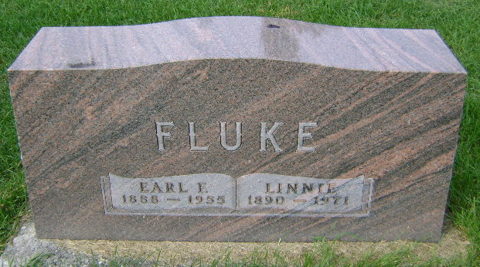
Photo by Bruce Sonner

Mrs. Linnie E. Fluke, 81, of Markle Route 1, widow of Earl F. Fluke died Monday at Clinic Hospital. A daughter of Jacob and Anna Warner Bronner, she was born in Huntington County, March 19, 1890. Her marriage to Mr. Fluke, who died in 1955, took place in Wells County April 5, 1911.
She was a member of the United Methodist Church at Zanesville.
Surviving are three daughters, Mrs. Denver (Anna Laura) Slater of Route 2, Bluffton, Mrs. Hubert (Frances) Smith of Roanoke, Route 2, and Mrs. Ralph (Elizabeth) Walker of West Unity, Ohio; a son, Jacob of Markle; two sisters, Mrs. Clayton (Mina) Herran of Markle and Mrs. Herschel (Guinnivere) Lesh of Route 1, Markle; 12 grandchildren and 11 great grandchildren.
Services will be Wednesday at the United Methodist Church at Zanesville with Dr. William Dean officiating; burial in Hoverstock Cemetery at Zanesville.

Wells County Indiana Obituaries
1969 - 1975

*****
Indiana, U.S., Death Certificates, 1899-2011

Name: Linnie E Fluke
[Linnie E Bronner]
Gender: Female
Race: White
Age: 81
Marital status: Widowed
Birth Date: 19 Mar 1890
Birth Place: Indiana
Death Date: 24 May 1971
Death Place: Bluffton, Wells, Indiana, USA
Death Registration Date: 1971
Father: Jacob Bronner
Mother: Anna Warner
Informant: Anna Laura Slater; daughter; Bluffton, Indiana
Burial: May 26, 1971; Hoverstock Cemetery; Zanesville, Indiana

