Billy Dean Fisher
September 12, 1937 – November 28, 2016

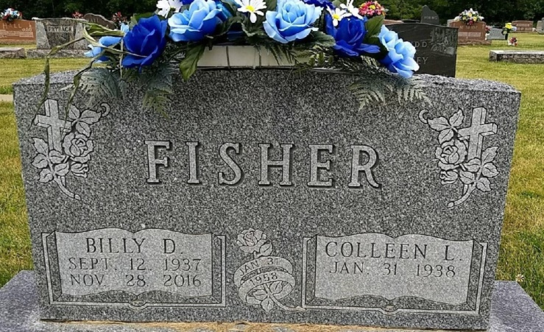
Photo by Bruce Sonner

Bill D. Fisher, 79 of Markle passed away at 3:29 am on Monday, November 28, 2016 at Lutheran Hospital. Bill was a 1955 graduate of East Union High School. He drove a school bus for Northern Wells Community Schools for 38 years, retiring in 2005. He was a lifetime farmer in Wells County. Bill was a member of the Warren Church of Christ. He bowled for over 40 years in the Bluffton Church League. Bill enjoyed going to Norwell Basketball games, he generally enjoyed the outdoors.
Bill was born on September 12, 1937 in Wells County, the son of Donald F. and Ruby M. (Burgess) Fisher. He was united in marriage to Colleen Moore on January 31, 1958 at Nine Mile. His wife survives.
Additional survivors include three sons: Gary (Glennda) Fisher of Uniondale; Barry (Michelle) Fisher of Berne; Perry (Janice) Fisher of Markle; a sister: Bonnie Denly of Detroit Lakes, MN; eight grandchildren and six great grandchildren.
He was preceded in death by his parents: Donald and Ruby Fisher, a brother: Max D. Fisher, a sister: Helen Seaman and a granddaughter: Nicole Fisher.
Visitation will be held on Thursday, December 1, 2016 from 2:00 pm – 8:00 pm at the Myers Funeral Home Markle Chapel, 415 N. Lee Street, Markle, Indiana. Funeral service will be held on Friday, December 2, 2016 at 10:00 am at the Myers Funeral Home Markle Chapel with Pastors Ethan Stivers, Dal Fosnaugh and Richard Kees officiating. Interment will be at the Hoverstock Cemetery in Zanesville, Indiana.
Memorial donations can be made out to Visiting Angels or Warren Church of Christ, both in care of Myers Funeral Home, P.O. Box 403, Markle, IN 46770.

Myers Funeral Home, Huntington County, Indiana
November 29, 2016

