Harley D. Feighner
July 13, 1889 – June 5, 1919

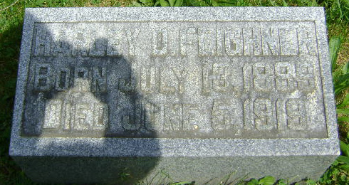
Photo by Bruce Sonner
Harley Feighner, aged 29 years, the son of Adam and Mary Feighner, died at 5:30 o'clock Thursday morning from hemorrhages of the lungs, at the family home near Zanesville. The parents and one brother, Dallas, at home, survive.
Funeral services will be held Sunday morning at 10 o'clock from the residence and at 11 o'clock from the United Brethren church at Zanesville, the Rev. Mr. Zartman officiating. Interment in the Zanesville Cemetery.

Fort Wayne News, Allen County, Indiana
June 6, 1919

*****
Indiana, U.S., Death Certificates, 1899-2011
Name: Haney D. Feighner
Gender: Male
Race: White
Age: 29
Marital status: Single
Birth Date: 13 Jul 1889
Birth Place: Indiana
Death Date: 5 Jun 1919
Death Place: Fayetteville, Allen, Indiana, USA
Death Registration Date: 1919
Father: Adam Feighner
Mother: Mary Hamilton
Informant: Adam Feighner; Zanesville, Indiana
Burial: July 8, 1919; Hoverstock Cemetery; Zanesville

