Dora F. (Jones) Feighner
February 24, 1891 – May 12, 1940

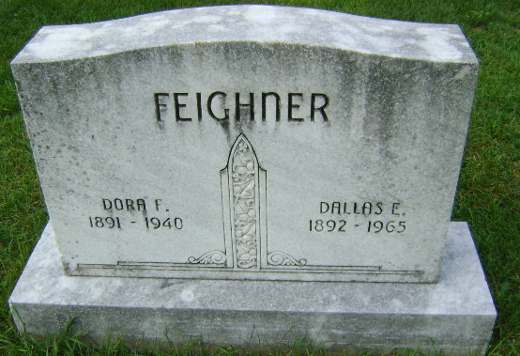
Photo by Bruce Sonner

CRASH VICTIM’S FUNERAL TODAY
Funeral services for Mrs. Dora F. Feighner, 49, of near Zanesville, who was killed in an automobile collision at Huntington Sunday night, will be held at 3:30 pm (CDT) today at the residence and at 4 pm at the Zanesville U.B. Church. Rev. John Paul Pack of Huntington will officiate and burial will be in Zanesville Cemetery.
Mrs. Feighner suffered a fracture of the skull when automobiles drive by her husband, Dallas E. Feighner, and by Lee Andrea of R.R. No. 5, collided at the east edge of Huntington and plunged into the bed of the old Wabash-Erie Canal. Mrs. Feighner, a native of Union Township, Wells County, was a member of the Central Christian Church at Huntington.
She is survived by the husband; one son, Darrell Feighner, at home; one daughter, Mrs. Paul PeGan of Huntington; one grandchild; her father, Franklin Jones of Lafayette Township; two brothers, Dee Jones of Lafayette Township and Wiley Jones of near Roanoke, and two sisters, Mrs. Manuel Smith of Fort Wayne and Mrs. Clyde Young of Lafayette Township.
The body is at the residence. The Koontz Funeral Home of Roanoke is in charge of arrangements.
Journal-Gazette, Allen County, Indiana
May 14, 1940

*****
Indiana, U.S., Death Certificates, 1899-2011
Name: Dora F Feighner
[Dora F Jones]
Gender: Female
Race: White
Age: 49
Marital status: Married
Birth Date: 24 Feb 1891
Birth Place: Union Tp Wells Co Ind
Death Date: 12 May 1940
Death Place: Rural, Huntington, Indiana, USA
Father: Ellis Franklin Jones
Mother: Elma Lawrence
Spouse: Dallas E Feighner; age 49 years
Informant: Dallas Feighner; Roanoke, Indiana
Burial: May 14, 1940; Hoverstock Cemetery; Zanesville, Indiana

