Gerald E. DeBolt
September 24, 1926 – March 5, 2001

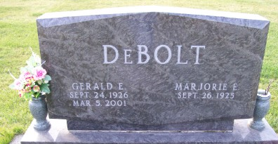
Photo by Scott Shoup

Markle - Gerald E. DeBolt, 74, died Monday at Highlands Hospital, Sebring, Fla. Born in Berne, he retired in 1980 as an inspector on the motor line at International Harvester after 34 ½ years.
Surviving are his wife, Marjorie E.; two daughters, Tonya L. Cossairt of Markel and Wanda L. Frantz of Bluffton; four sons, Eugene DeBolt of Battle Creek, Mich., Gary A. Myers of Decatur, Westly DeBolt of Hagerstown and Jerry DeBolt of Churubusco; two brothers, Marion L. of Decatur and Floyd Wayne of Bluffton; 16 grandchildren and seven great-grandchildren.
Services at 11 a.m. Saturday at Markle Church of Christ with calling one hour before services. Calling also from 2 to 4 and 6 to 8 p.m. Friday at Elzey & Haggard Ossian Chapel. Burial in Hoverstock Cemetery, Zanesville.

Berne Library Heritage Room, Adams County, Indiana
Misc. Obits
Handwritten date: March 5, 2001
*****

U.S., Social Security Death Index, 1935-2014
Name: Gerald E. Debolt
Social Security Number: xxx
Birth Date: 24 Sep 1926
Issue Year: Before 1951
Issue State: Indiana
Last Residence: 46770, Markle, Huntington, Indiana, USA
Death Date: 5 Mar 2001

