Mary Madeline (Jones) Dafforn
November 7, 1913 – December 31, 1999

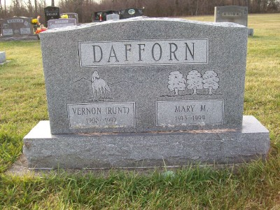
Photo by Scott Shoup

Mary M. Dafforn, 86, of Ossian, died at 8:30 p.m. Friday (Dec. 31, 1999) at Lutheran Hospital, Fort Wayne. Mrs. Dafforn was a homemaker and a member of the Zanesville United Brethren in Christ Church. She was a 1930 graduate of East Union High School.
She was born Nov. 7, 1913 in Wells County, the daughter of Charles and Ora Jacobs Jones. On April 7, 1933, in Michigan, she married Vernon Dafforn. He died on Dec. 30, 1992.
Survivors include three sons, Lynn Dafforn, of Markle, Jack Dafforn, of Ossian, and Dan Dafforn, of Fort Wayne; 11 grandchildren, four step-grandchildren, nine great grandchildren and six step-great grandchildren. She was preceded in death by a son, Kirby Dafforn, one brother and one sister.
Calling is from 2-4 p.m. and 6-8 p.m. Monday at Myers Funeral Home, Markle Chapel, and one hour before the 11 a.m. funeral service Tuesday at Zanesville United Brethren in Christ Church, Zanesville. Pastor Tom Datema will officiate at the service. Burial will be at Hoverstock Cemetery, Zanesville. Memorial contributions may be made to Zanesville United Brethren in Christ Church.

Huntington Herald Press
January 3, 2000

