John Owen Cope
January 10, 1952 – January 10, 1952

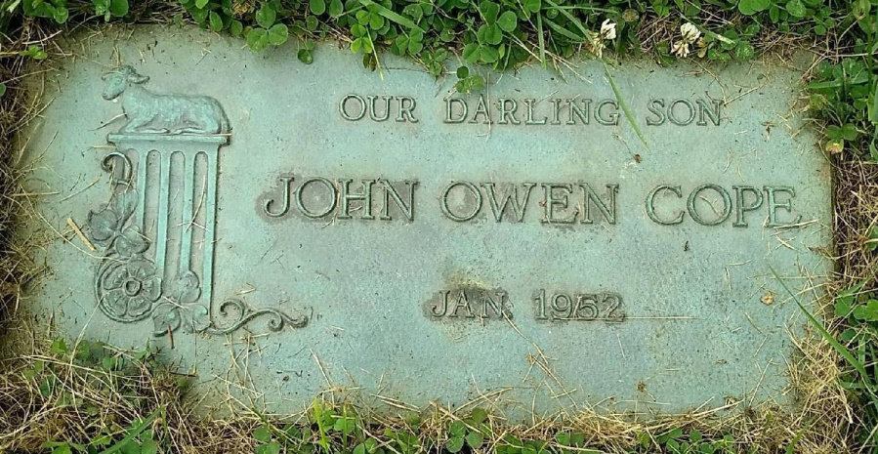
Photo by Beverly Wagner

No further information found at this time

