Melvin R. Clark
1909 -

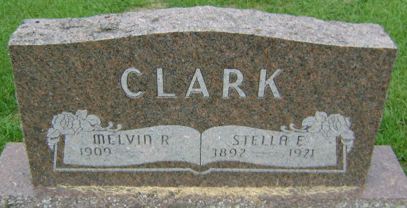
Photo by Bruce Sonner

No obit found at this time

