Alvin Chaney
August 2, 1897 – September 16, 1897

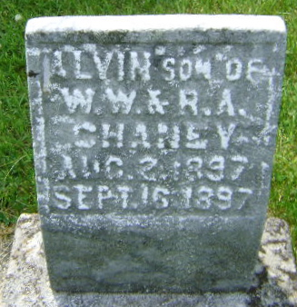
Photo by Bruce Sonner

No further information found at this time

