Dr. E. E. Carroll
October 24, 1824 - May 31, 1864

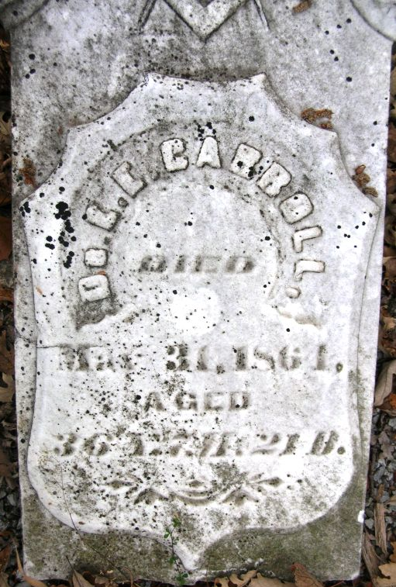
Photo by Bruce Sonner

No further information found at this time

