Neva LaKren Carpenter
February 19, 1922 – April 27, 1923

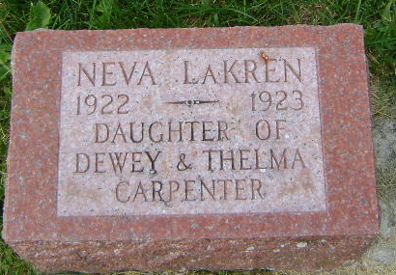
Photo by Bruce Sonner

Neva C Carpenter
in the Indiana, U.S., Death Certificates, 1899-2011
Name: Neva C Carpenter
Gender: Female
Race: White
Age: 1
Marital status: Single
Birth Date: 19 Feb 1922
Birth Place: Indiana
Death Date: 27 Apr 1923; scarlet fever
Death Place: Zanesville, Wells, Indiana, USA
Father: Dewey Carpenter
Mother: Thelma Fisher
Informant: Elmer Fisher
Burial: April 28, 1923; Zanesville Cemetery

