Elizabeth Bowman
June 30, 1804 - June 18, 1889

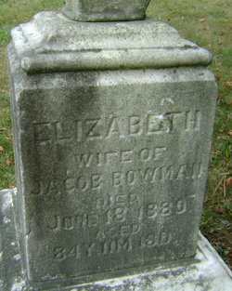

Photo by Bruce Sonner

No obit found at this time

