Sarah Beiler
December 12, 1828 – December 18, 1864

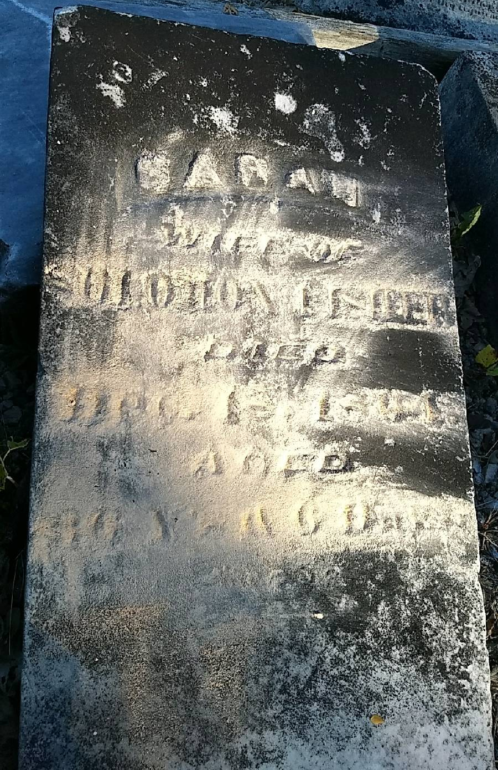
Photo by Beverly Wagner

No further information found at this time

