Alwilda (Jennings) Beaty
April 16, 1849 – August 19, 1872

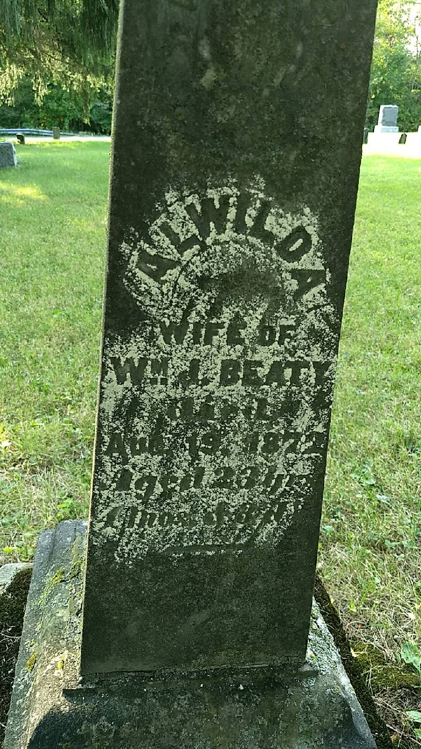
Photo by Beverly Wagner

No further information found at this time

