Daniel B. Bailey
March 16, 1915 – May 7, 1973

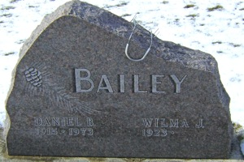
Photo by Bruce Sonner

Daniel B. Bailey, 58, a resident of Zanesville, Indiana died Monday at the Lutheran Hospital, Fort Wayne. He was born March 16, 1915 in Wells County, a son of Eldon and Sarah Weikel Bailey. He was married September 5, 1942 to Wilma Porter in Wells County. She survives.
He was a member of the United Brethren in Christ Church at Zanesville.
Surviving in addition to the wife are four sons, Kedric of Route 1, Markle, Thomas of Route 2, Ossian, Roger of Zanesville and Donald of Crestline, California; two brothers, Delores of Roanoke, Indiana and Ivan of Route 1, Yoder, and seven grandchildren.
Services will be Thursday at the United Brethren in Christ Church at Zanesville with Rev. Larry Taylor officiating; burial in Hoverstock Cemetery at Zanesville.

Bluffton News-Banner, Wells County, Indiana
May 7, 1973

