Deborah D. (Walquist) Arnett
July 24, 1961 -

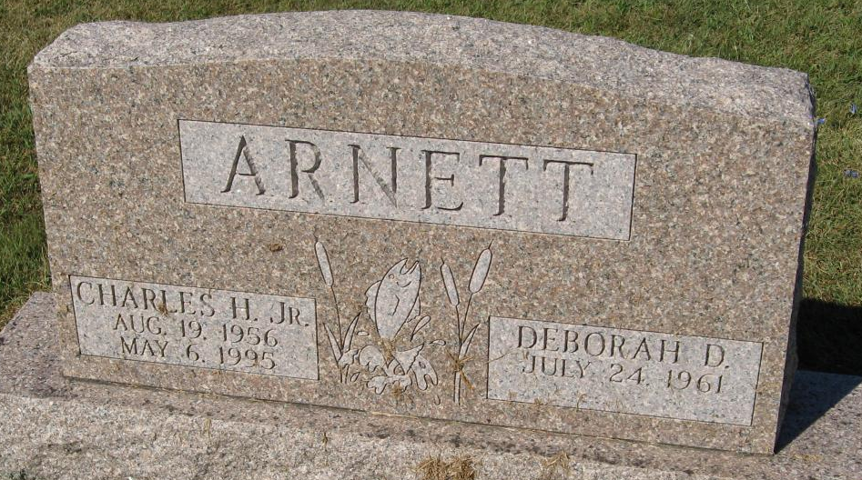
Photo by Tombstoner & Family

