William Arbaugh
June 29, 1868 – June 21, 1934

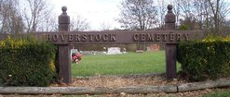

William Arbaugh
in the Indiana, U.S., Death Certificates, 1899-2011
Name: William Arbaugh
Gender: Male
Race: White
Age: 65
Marital status: Widower
Birth Date: 29 Jun 1868
Birth Place: Ohio
Death Date: 21 Jun 1934; accidental burns at county infirmary
Death Place: Perry, Allen, Indiana, USA
Father: Daniel Arbaugh
Mother: Margaret Walters
Informant: Clarence Page; County Infirmary
Burial: June 24, 1934; Zanesville, Indiana

