Belinda Jean (Wilson) Hunnicutt
October 22, 1962 – February 18, 2011

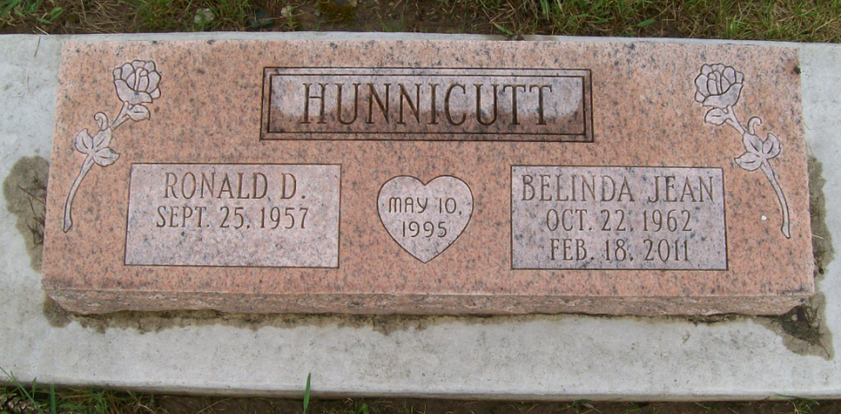
Photo by Scott Shoup

Belinda, 48, of Fort Wayne, formerly of Huntington, Friday at Parkview Hospital in Fort Wayne. Belinda was a 1981 Graduate of Huntington North High School. She was a homemaker and had previously worked at Seiferts Potato Chips and Meijer Stores in Fort Wayne. She had a strong faith in the Lord.
She was a daughter of Raymond E. and Patricia (Harshman) Wilson. She was united in marriage to Ron Hunnicutt on May 10, 1995 in Huntington. Her husband survives.
Additional survivors include - her mother: Patricia Wilson of Huntington, a brother: Louis Wilson of Huntington; 4 sisters: Rosemary Bailey of Huntington, Diann Wilson of Huntington, Belva Bircham of Warren and Refa Chopson of Huntington.
Services were Private Family Services only at the Myers Funeral Home, Markle Chapel, IN. Preferred memorials are to the American Cancer Society.

Myers Funeral Home online obit (accessed February 19, 2011)

