Evelyn Neoma (Barrick) Hanni
March 31, 1934 – March 17, 2011

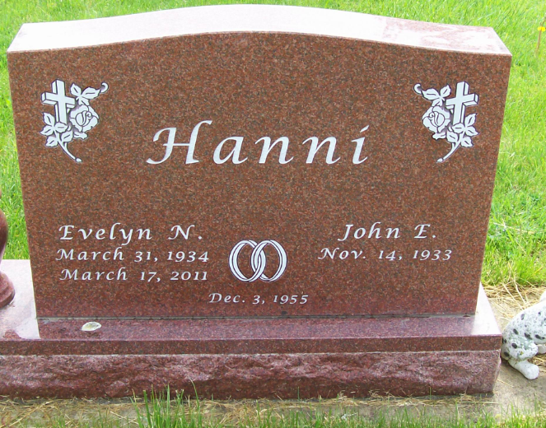
Photo by Scott Shoup

Evelyn Neoma Hanni, 76, of Uniondale passed away on Thursday morning at Lutheran Hospital in Fort Wayne. Mrs. Hanni was born on March 31, 1934 in Uniondale, Indiana to Olive W. & Millie D. (Campbell) Barrick. She graduated from Lancaster High School with the class of 1952. On December 3, 1955 at the Epworth United Methodist Church, she married John Hanni. John and Evelyn have shared the last 55 years together. He survives in Uniondale.
A homemaker, she was a devoted mother to her two daughters Cynthia (husband Steve) Cook of Brownsburg, IN and Mary Jane (husband Barry) Brown of Fort Wayne, and loving grandmother to six grandchildren; Erika (husband Jeff) Scheck, Thomas, Jonathon & Brian Cook, Jillian & Melita Brown, along with 3 great grandchildren. She is also survived by a brother Merlin (wife Corrina) Barrick of Bluffton.
John and Evelyn also served as a guardian/advocate for Ron Malone who was a gentleman with a developmental disability that they opened their home and hearts to. She served on the Election Board for many years, loved to camp, sew and read and spend time with her family. She was an active member of St. Mark’s Lutheran Church in Uniondale, where she was a member of the Women's Group. She had a special place in her heart for the family dogs, including Misty that has been part of the Hanni House for the last 12 years.
Friends are invited to visit with the Evelyn's family from 1 to 7 on Sunday at the Thoma/Rich, Chaney & Lemler Funeral Home in Bluffton. Funeral services will be at 10:30 Monday (March 21, 2011) at St. Mark’s Lutheran Church, Uniondale with calling for one hour prior to the service. Pastor Richard Vonesh will officiate. Burial will follow at Horeb Cemetery just west of Uniondale.
Memorials may be made to the St. Mark’s Lutheran Church.

Thoma/Rich, Chaney & Lemler Funeral Home online obit (accessed
March 18, 2011)

