Bonnie L. (Herrick) Hall
August 12, 1935 – January 8, 2013

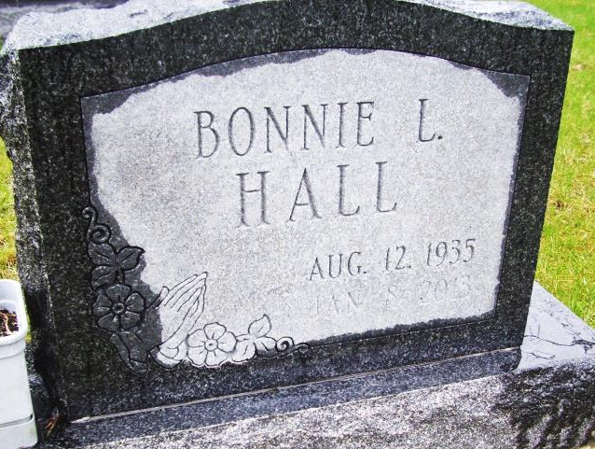
Photo by LMafera

Bonnie L. Hall, 77, of Murray, Indiana and formerly of Fort Wayne, passed away at 3:45 a.m. Tuesday, January 08, 2013 at Ossian Health Care. Bonnie was born in Bluffton on August 12, 1935 to Othal and Charlotte (Mossburg) Herrick. She graduated from Lancaster High School and was later trained as a respiratory therapist. She worked as a respiratory therapist for 17 years at Lutheran Hospital. In her retirement Bonnie enjoyed going to garage sales and playing bingo.
Bonnie is survived by a son, Kevin L. (Jane) Baller of Ossian, a daughter, Dawn D. Malone, of Fort Wayne, a brother, John (Karen) Herrick of Ossian, four grandchildren, Hollie, Amie, Kurtis, and Chad. In addition to her parents, she is preceded in death by a sister, Barbara Myers.
Private family visitation will be Thursday at Thoma/Rich, Chaney & Lemler Funeral Home. A private family service celebrating Bonnie's life will follow the visitation on Thursday at the funeral home with Certified Funeral Celebrant Jeff Lemler officiating. Burial will be in Horeb Cemetery. Preferred memorials are to the United Way of Wells County.

Thoma/Rich Chaney & Lemler Funeral Home online obit (accessed January 9, 2013)

