Jacob Haflich
September 30, 1816 – April 16, 1897

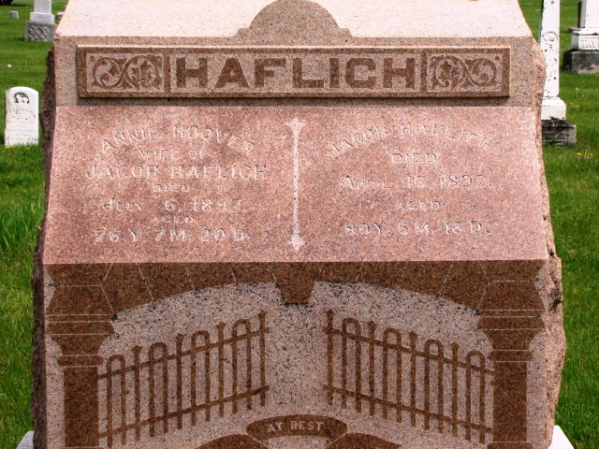
Photo by Barbara Baker Anderson

The funeral of Jacob Haflich, of Markle, occurred April 18th, 1897. A very large attendance gathered at the residence and proceeded to the Horeb Church, where the house was already crowded. The funeral service was conducted by the pastor, Rev. Robt. Atkin of Uniondale, using the text Prov. XVI 31. The remains were laid to rest in a beautiful casket interred in the Horeb Cemetery.
Jacob Haflich was born in Penn., September 30, 1816. At the age of 16 or 17 he accompanied his parents to Rutland County. He was married to Anna Hoover, October 28, 1841. The following winter they united with the Lutheran Church. In 1848 he moved to Wells County, Indiana. To them were born six children, four of whom have crossed to the other shore. He leaves a wife and two children to follow after.
Father Haflich was one of the prime movers in the establishment of the Horeb Church. In his death the community has lost a good and upright citizen, the church a faithful member, the wife a kind and loving husband and the children an indulgent father.
The best comment on his life is his deeds of which the families have no need to be ashamed. Jacob Haflich closed his labors April 16, 1896, aged 80 years, 6 months and 16 days.

Bluffton Banner, Wells County, IN; April 21, 1897

