Keith Edward Garwick
April 30, 1949 – April 17, 2008

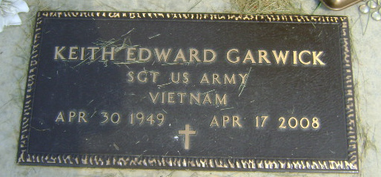
Photo by Bruce Sonner

Keith Edward Garwick, 58, of Uniondale, died at 3 a.m. Thursday, April 17, 2008, at his residence.
Born in Celina, Ohio on April 30, 1949 to Ernest and Loretta Naomi (Kendall) Garwick, he married Janet Raymond in Hart, Mich., on Dec. 4, 1982; she survives. A graduate of Celina High School, Mr. Garwick was served in the U.S. Army from 1968 to 1971 during the Vietnam War and was a member of VFW in Celina, Ohio. He worked as a contract telephone wire splicer for Alltel in Ossian and then Verizon in Fort Wayne for 21 years.
Also surviving are two sons, Nick (Fiancé: Miranda Leffers) Garwick of Fort Wayne and Matt (Fiancé: Keri Dahn) Garwick of Uniondale, presently attending college in Lima, Ohio; and one brother, Dan (Anji) Garwick of Huntington Beach, Calif.
Mr. Garwick was also preceded in death by one brother, Richard Garwick.
Funeral services will be at 2 p.m. Sunday, at the Thoma/Rich, Chaney & Lemler Funeral Home in Bluffton with Pastor Troy Drayer officiating. Calling hours will be from 2 to 4 p.m. and 5 to 8 p.m. Saturday at the funeral home. Burial is at Horeb Cemetery. Military Graves Site rites will be performed by the American Legion Post #111 of Bluffton and the United States Army Honor Guard.
Preferred memorials are to the American Diabetes Association or Uniondale Fire Department.
Thoma/Rich, Chaney & Lemler Funeral Home online obit (accessed 7/13/2018)

