Sandra Jeannine Gardenour
November 19, 1935 – March 25, 2011

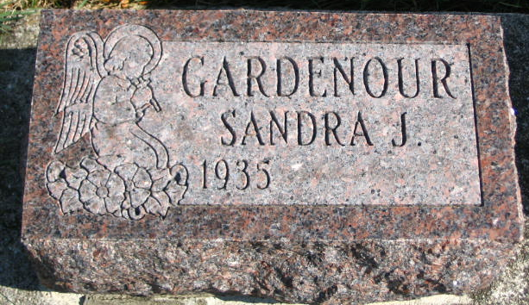
Photo by Barbara Baker Anderson

Sandra "Sandy" Jeannine Gardenour of 1630 S. County Farm Road, Warsaw, Indiana passed away on Friday, March 25, 2011 at 7:45 a.m. at Miller's Merry Manor of Warsaw at the age of 75. She was born on November 19, 1935 in Bluffton, Indiana to Farrell Englis Gardenour and Justine B. (Brickley) Gardenour. She spent most of her life in the Uniondale, Indiana area and several years in a Group Home in Decatur, Indiana. As her health declined Sandy was relocated to Warsaw. Sandy was a member of the Uniondale United Methodist Church and while living in Decatur she attended Bi-County Services.
She will be lovingly remembered by her sister, Jane Brallier (Winona Lake, Indiana); and two nephews, Kirk (spouse Linda) Swaidner (Winona Lake, Indiana); Scott (spouse Nannette) Swaidner (Pierceton, Indiana). She was preceded in death by her parents.
A graveside service will be conducted on Saturday April 9, 2011 at 11:00 a.m. at Horeb Cemetery, Markle, Indiana. Arrangements were entrusted to Redpath-Fruth Funeral Home, 225 Argonne Road, Warsaw, Indiana.

Unknown source

