Kendrick Dean Eversole
November 8, 1930 – July 13, 2012

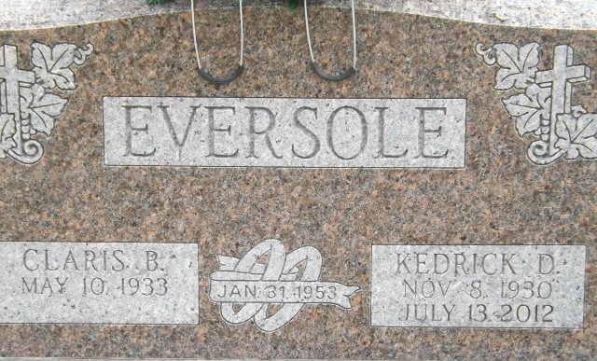
Photo by Bruce Sonner
Kedrick Dean Eversole, passed away, Friday July 13, 2012 in Plant City, Fla. He was born on November 8, 1930 in Uniondale to Wm. Kenneth and Elizabeth A. (Brickley) Eversole. His mother said she chose his name after hearing a baby born the prior year in the area named Kedrick Fishbaugh. Kedrick and his older brother grew up in Rockcreek Township helping on their parent's farm southwest of Uniondale. Not being able to take the farm out of the boy, he spent the next 50 years farming until moving to Lake Placid, Fla. where he met up with other Midwestern farmers, joining the Florida Flywheeler's Antique Engine club in south Polk County. Flywheeler's gave him a place to show off his passion in restoring tractors and competing in tractor pulls. He served as a platoon sergeant with Company K of the 17th Infantry Regiment. He entered the Army in May 1951, arriving in Korea in December 1951. He was awarded the Combat Infantryman Badge, United Nations Ribbon, and the Korean War Campaign Ribbon. "He had a larger than life laugh, a love of tractors, and a desire to lend a helping hand."
Surviving family include his wife, Claris Belle (Buskirk), whom he married on January 31, 1953 in Nine Mile, IN; children, Vance Dean (Terrie) of Argyle, Texas, Gail Lee (Deb) of Woodburn, Ind., Twylla Jean (Mike) Bell of Plano, Texas, and Clarene Beth (Jim) Benton of Plant City, Fla.; brother, William K. "Bill" Eversole Jr.; seven grandchildren, and six great-grandchildren. Besides his parents, he was preceded in passing by a daughter, Lynette Ann Moran in March of 2005.
Funeral service is 1 p.m. on Wednesday, July 18, 2012 at Elzey-Patterson-Rodak Funeral Home, 120 West Mill Street, Ossian with visitation one hour prior. Visitation will also be from 4 to 8 p.m. on Tuesday, July 17, 2012 at the funeral home. Burial will be at Horeb Cemetery. Memorials may be made to Dundee United Methodist Church, 219 East Merrill Ave., Dundee, FL 33838.

Journal-Gazette, Fort Wayne, IN; July 16, 2012

