Rosetta Belle (Griffin) Duff
July 26, 1880 – June 29, 1949

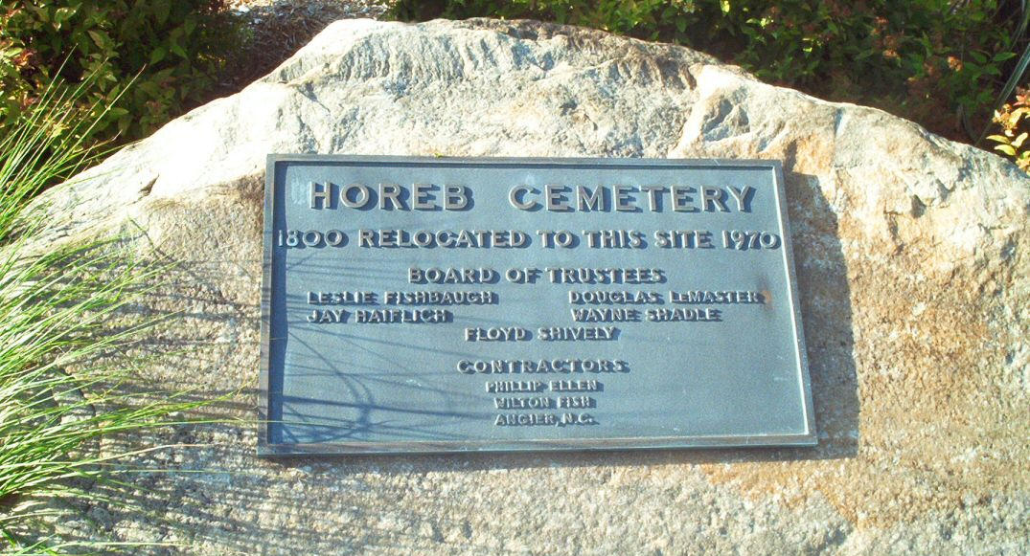
Photo by Tombstoner & Family

Indiana, Death Certificates, 1899-2011

Name: Rosetta Belle Duff
[Rosetta Belle Griffin]
Gender: Female
Race: White
Age: 68
Marital Status: Widowed
Birth Date: 26 Jul 1880
Birth Place: Indiana
Death Date: 29 Jun 1949
Death Place: Ft Wayne, Allen, Indiana, USA
Father: Weshey Griffin
Mother: Sarah Jane Folk
Informant: Mrs. Herman Fogwell, Ft. Wayne, Ind.
Burial: July 1, 1949; Mt. Horeb Cem., s/o Markle, Ind.

