Jill Ann (Stabler) Dreyer
May 18, 1961 – February 22, 2003

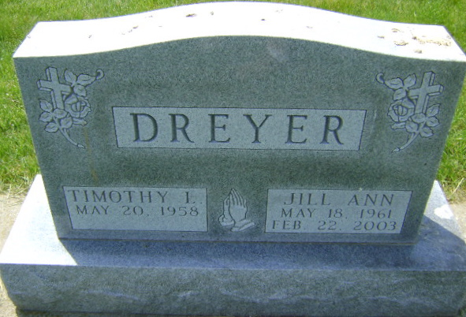
Photo by Bruce Sonner

Jill Ann Dreyer, 41, a nurse and member of the Murray Missionary Church, died Saturday, Feb. 22, 2003, at home.
The Fort Wayne native worked at the Caylor-Nickel Clinic for six years and then at Huntington Hospital for the last 13 years. She was active with the Wells County Horse and Pony Club, and loved gardening.
Surviving are her husband, Tim; a son, Mike of Uniondale; a daughter, Erin Baumgartner of Uniondale; her parents, Lawrence and Suzanne Stabler; a brother, Rick of Milwaukee, Wis.; and a sister, Kelly Norris of Huntington.
Services are 2 p.m. Tuesday at Thoma/Rich, Hewitt & Chaney Funeral Home in Bluffton. Calling will be from 2 to 5 and 6 to 9 p.m. today at the funeral home. Burial will be at Horeb Cemetery, Uniondale.
Memorials are to the American Cancer Society, Parkview Hospice of Huntington or the church.

News-Sentinel, Fort Wayne, IN; February 24, 2003

