Joseph Tillman Derr
March 17, 1836 – September 8, 1910

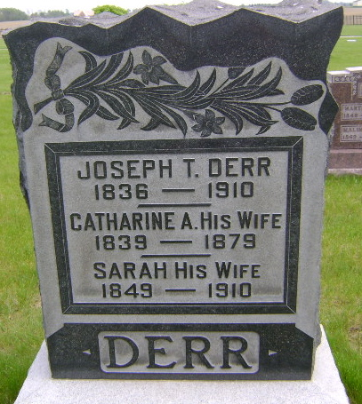
Photo by Bruce Sonner

JOSEPH DERR DEAD AT MARKLE
FATHER OF CLARENCE DERR OF THIS CITY PASSED AWAY THURSDAY NIGHT
Joseph T. Derr, of Markle, father of Clarence Derr of this city, died Thursday evening at 7 o'clock after an illness of many months, death being due to infirmities of advanced age. Mr. Derr at his death was 74 years old. He was born and raised in Pennsylvania and in the year 1863 moved to Indiana and settled near Markle, where he since resided. He was twice married his second wife dying last May.
The surviving children are Mrs. Jacob Redding, living near Markle; Edward Derr, living in Landis, Wisconsin, Clarence, of this city, Mrs. C. Walker of this county, and Mrs. Will A. Brickley of Montpelier; Mrs. Will Lew of Markle and George Derr.
The funeral will be held Sunday with burial at Horeb Church in Rockcreek Township. Mr. Derr was an active member of the Methodist Church at Markle.

Bluffton Chronicle, Wells County, IN; September 8, 1910

