Alfred Brickley
February 28, 1834 – July 19, 1907

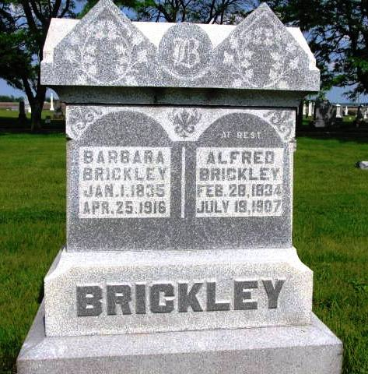
Photo by Barbara Baker Anderson
Another Pioneer Passed to His Reward
Alfred Brickley a prominent Rockcreek Township Farmer Died Friday Morning

The death of Alfred Brickley, one of the oldest residents of Wells County, occurred Friday morning at two o’clock at his home in Rockcreek Township. He had been in poor health for several years, but the last eight months was almost entirely helpless. His death was due to diseases accompanying old age.
Alfred Brickley was born February 28, 1834 and was 73 years, 4 months and 21 days old at the time of his death. He was married to Barbara Harflich more than fifty years ago.
To this union twelve children were born five of whom are living. They are Mrs. J. R. Ditzler, Lewis Brickley, Mrs. John Gardenour, Joshua and George Brickley. The wife also survives him.
After his marriage, he with his wife, settled on a farm in Rockcreek Township, and they have lived there continuously ever since. Energetic, he had cleared away the forest and became one of the prosperous farmers in that vicinity. He served the township as trustee and six years as assessor, performing the services faithfully and well, and was familiarly called “Uncle Alfred.”
Mr. Brickley served his country in the Civil War, enlisting in Co. H., 51st Indiana Regiment. He was a member of the Lew Dailey Post of this city. He was also a faithful member of the Lutheran Church.
The funeral was held Sunday at the Horeb Church, the funeral cortege leaving his late home at ten o’clock. Rev. Greenawalt, his pastor, will have charge of the services. Interment took place in the Horeb Cemetery.

Bluffton Chronicle, Wells County, IN; July 24, 1907

