Gladys Allegra (Lesh) Becker
April 4, 1902 – September 26, 2001

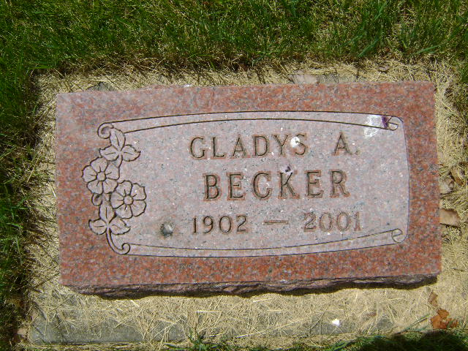
Photo by Bruce Sonner

Gladys A. Becker, 99, of Markle, died at 6:15 a.m. Wednesday, Sept. 26 at the Markle Health Care Center.
Mrs. Becker worked as a receptionist/clerk for 25 years at the Markle Drug Store. She attended the United Methodist Church at Markle. She was born in Markle Aug. 4, 1902, a daughter of Douglas and Lillian Kelsey Lesh.
Surviving are a sister, Hilda Lesh of Fort Wayne, and two nephews, Douglas LeMaster of Howe and Charles LeMaster of Fort Wayne.
A sister, Lucille LeMaster, and a nephew are deceased.
Services will be at 10 a.m. Saturday at Myers Funeral Home Markle Chapel and interment will be in Horeb Cemetery near Uniondale.
Visitation hours at the funeral chapel will be Friday from 2 to 4 and 6 to 8 p.m. Memorials to the Markle Park Foundation or to the Markle United Methodist Church.

Myers Funeral Home online obit (accessed September 27, 2001)

