Jacob Alshouse
November 20, 1835 – May 31, 1917

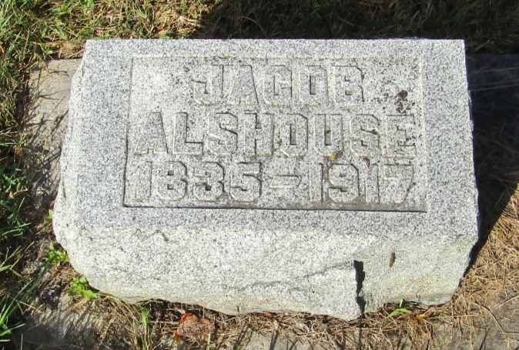

Jacob Alshouse
in the Indiana, U.S., Death Certificates, 1899-2011
Name: Jacob Alshouse
Gender: Male
Age: 81
Marital status: Widowed
Birth Date: 20 Nov 1835
Birth Place: Ohio
Death Date: 31 May 1917
Death Place: Markle, Huntington, Indiana, USA
Father: Henry Alshouse
Spouse: Sarah E.; deceased
Informant: Geo Alshouse; Markle, Indiana
Burial: June 2, 1917; Horeb Cemetery

