Elizabeth Alshouse
1906 - 1906

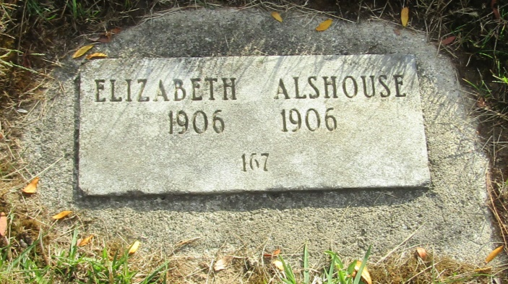

No further information found at this time

