Iva Mae (Summers) Allen-Wygant
May 7, 1916 – September 25, 2007

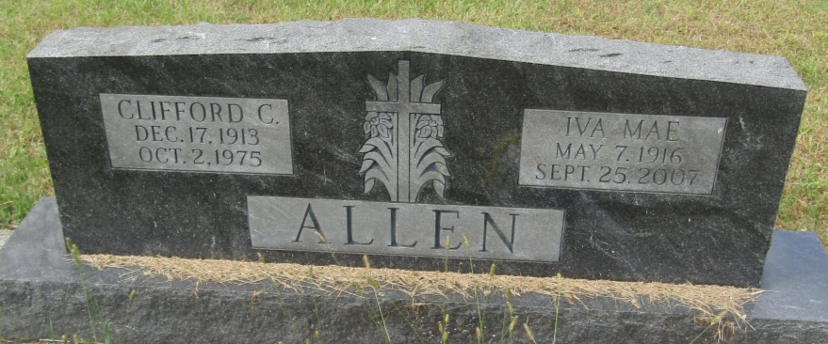

Iva Mae Wygant, 91 of Heritage Pointe, Warren and formerly of Markle died at 1:20 AM on Tuesday, September 25, 2007 at the Bluffton Regional Medical Center. She was a member of the Markle United Methodist Church and was also a member of Order of the Eastern Star Crescent Chapter #48 of Bluffton.
She was a 1934 graduate of Markle High School. She had worked for 18 years at Lincoln Life Insurance Company, retiring in 1977.
She was born on May 7, 1916 in Huntington County, the daughter of Ira and Joyce (Armstrong) Summers. She was united in marriage to Clifford C. Allen on September 15, 1934 in Markle. He preceded her in death on October 7, 1975. Her second marriage was to W. Kell Wygant on January 6, 1990 in Markle. He preceded her in death on September 24, 2001.
Survivors include two daughters: Joyle S. Allen of Markle, Phyllis Lahr of Ft. Wayne, a son: Roger D. Allen of Albany, KY, 3 grandchildren and eight great grandchildren, six step grandchildren, eight step great grandchildren and one step great great grandchild. She was preceded in death by a brother: Kenneth Summers and a granddaughter.
Visitation will be held on Thursday, September 27, 2007 from 4:00 – 8:00 PM at the Myers Funeral Home Markle Chapel, 415 N. Lee Street, Markle, Indiana. Services will be held on Friday, September 28, 2007 at 11:00 AM at the Myers Funeral Home Markle Chapel with Rev. Kathie Jones officiating. Interment will be at the Horeb Cemetery in Uniondale.
Memorials are to the Markle United Methodist Church in care of Myers Funeral Home, P.O. Box 403, Markle, IN 46770.

Myers Funeral Home, Huntington County, Indiana
September 26, 2007

