Pamela Sue (Crum) Allen
June 14, 1944 – July 29, 1991

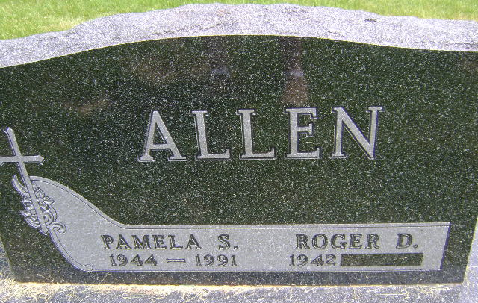
Photo by Bruce Sonner

Pamela S. Allen, 47, of Washington, Mich., died Monday in St. Joseph Hospital West, Mount Clements, Mich. The former Uniondale resident was an audit clerk for Mervyn's Department Store in Shelby, Mich.
Surviving are her husband, Roger D.; a daughter, Lisa B. Marsh of Fishers; sons, Richard D. and Robert D., both of Washington, Mich.; her parents, Maxine and Ardis Crum of Uniondale; and sisters, Linda Smith of Markle and Rita Rathburn of Auburn.
Services are 10:30 a.m. tomorrow in Markle United Methodist Church, with burial in Horeb Cemetery. Calling is 2 to 5 and 7 to 9 p.m. today in Myers Funeral Home, Markle.
Preferred memorials are gifts to Mindy Smith Cerebral Palsy Fund, 9395N and 200W, Markle 46770.

News-Sentinel, Allen County, Indiana
July 31, 1991

