James Victor Alexander
October 19, 1914 – June 4, 1979

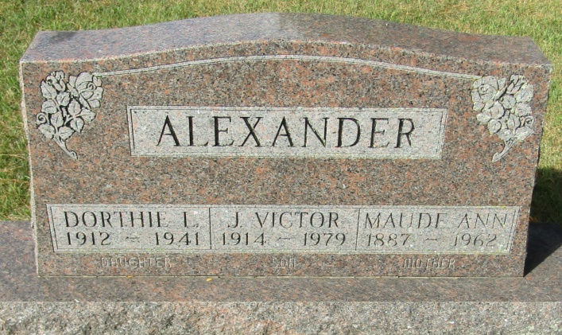

J. Victor Alexander
in the Indiana, U.S., Death Certificates, 1899-2011
Name: J. Victor Alexander
Gender: Male
Race: White
Age: 65
Marital status: Divorced
Birth Date: 19 Oct 1914
Birth Place: Michigan
Death Date: 4 Jun 1979
Death Place: Bluffton, Wells, Indiana, USA
Father: James K. Alexander
Mother: Anna Maude Taylor
Informant: Mrs. Alice Klaren; Fort Wayne, Indiana
Burial: June 6, 1979; Horeb Cemetery; Wells County, Indiana

