Alice L. (Crum) Alexander
September 12, 1919 – October 6, 2010

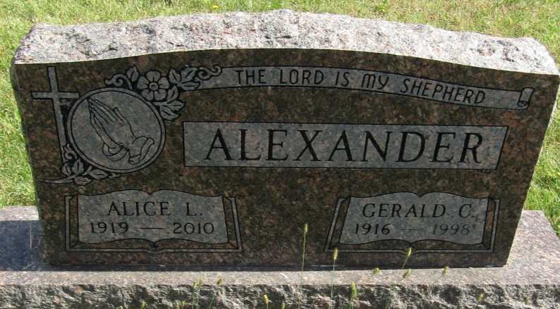

Alice Alexander, 91, passed away October 6, 2010 at River Terrace Estates. She was born in Uniondale on September 12, 1919 to the late Hubert and Clara Sink Crum. She lived in and around Uniondale all of her life. Alice graduated from Union Center in 1937. She worked at Casewell Furniture Co. in Huntington and Franklin Electric in Bluffton in the 1940's and then became a beauty operator with her own shop in Zanesville she later became a farmer's wife. Alice married Gerald Alexander in 1960 and they built a home North of Uniondale. Gerald died in January of 1998. She was also preceded in death by her brothers Dean, Merl and John.
She is survived by several nieces and nephews. Alice was a lifetime member of the St. Mark's Lutheran Church in Uniondale. She moved to Bluffton in February of 2002.
Funeral service will be 10:00 AM, Saturday, October 9, 2010 at Elzey Patterson Rodak Funeral Home, 120 West Mill St., Ossian with one hour of calling prior to service. Burial will be in Horeb Cemetery west of Uniondale. Pastor Richard Vonesh will be officiating.
Memorials are to St. Mark's Lutheran Church of Uniondale.

Elzey-Patterson-Rodak Funeral Home, Allen County, Indiana
October 7, 2010

