Ray O. Abner
February 14, 1924 – September 1, 2014

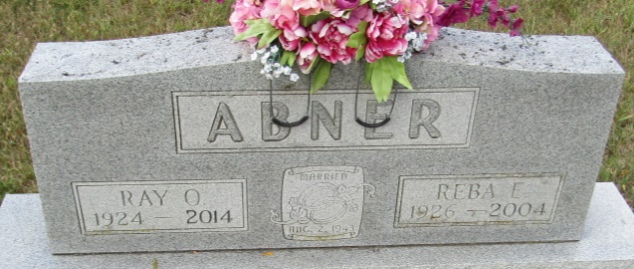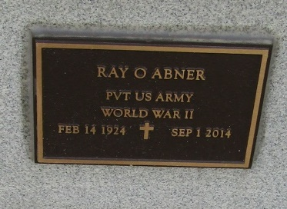

Ray O. Abner, 90, of Ossian, passed away early Monday morning Sept. 1, 2014 at the Ossian Healthcare and Rehabilitation Center.
Ray had worked for Franklin Electric for 15 years. He was a World War II Army veteran. Ray also had attended the Ossian United Methodist Church. He enjoyed woodworking, taking his grandchildren fishing, playing cards and bingo and Wii bowling.
Ray was born Feb. 14, 1924 in Wayne County, Ky., a son of Luther and Nettie (Morrow) Abner.
He was united in marriage to Reba E. Sullivan Aug. 2, 1943 in Jamestown, Ky. She preceded him in death on Aug. 20, 2004. He was preceded in death by two brothers, Gene Abner and Joe Abner; three sisters, Bessie Henthorne, Mossie Crispin and Margie Monhollen; and a son-in-law, Paul Bower.
Visitation will be held on Wednesday, Sept. 3, from 3 to 7 p.m. at the Myers Funeral Homes, Markle Chapel, 415 N. Lee St., Markle.
Funeral service will be held on Thursday, Sept. 4, at 10:30 a.m. at the funeral home. Interment will be at the Horeb Cemetery, Uniondale.
Memorial donations may be made out to Ossian Healthcare and Rehabilitation, sent in care of the funeral home.

Myers Funeral Home, Huntington County, Indiana
September 2, 2014

