Roy Delbert Whitsell
April 1, 1884 – June 10, 1969

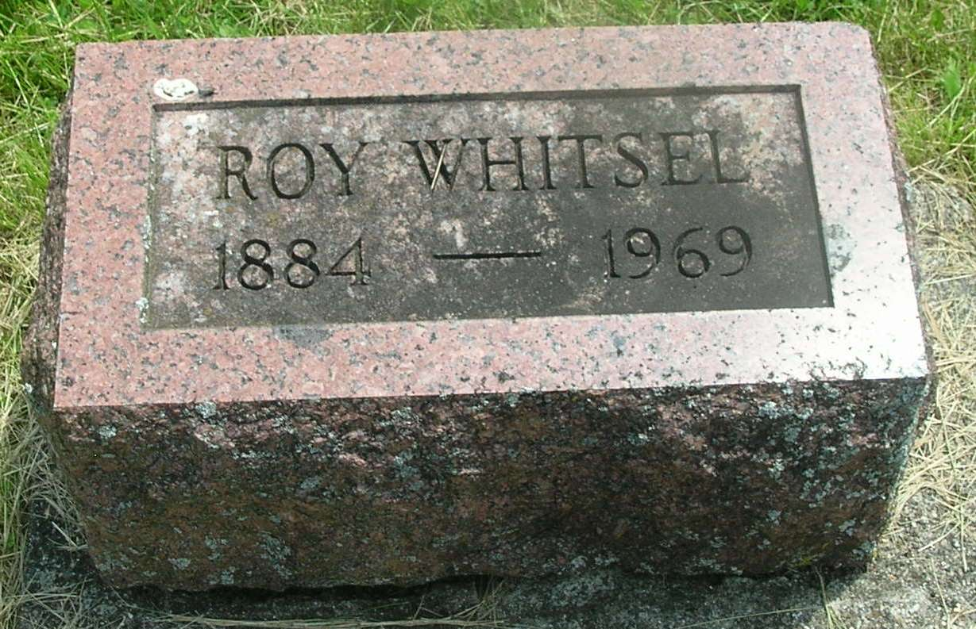

Roy Delbert Whitsell
in the Indiana, Death Certificates, 1899-2011
Name: Roy Delbert Whitsell
Gender: Male
Race: White
Age: 85
Marital status: Never Married (Single)
Birth Date: 1 Apr 1884
Birth Place: Indiana
Death Date: 10 Jun 1969
Death Place: Bluffton, Wells, Indiana , USA
Father: Joseph Whitsell
Mother: Lucinda Foust
Informant: Alva Penrod; friend; Bluffton, Ind.
Burial: June 12, 1969; Gearnand Cem., Reiffsburg, Ind.

